

PowerSource Training

PowerSource Defined

The PowerSource technology provides Prospector with a dynamic rule based engine that significantly enhances the users’ ability to leverage existing shop techniques and experience. With PowerSource you create intelligent rules that are evaluated at runtime to specifically tailor Prospectors behavior to the current part conditions, operator skill level, specific shop rules or type of part.

These intelligent rules allow Prospector to evaluate status of attributes like amount of remaining stock, cutter information, surface information and more, while cutter paths are being created. This information is continuously evaluated through PowerSource and used to suggest appropriate machining strategies and methods that produce efficient and error free cutter paths that conform to shop rules and best practices.

From the above definition we learn that PowerSource has these attributes:
- Rules based engine
- User created rules
- Rules execute dynamically while Prospector is running
- Prospector continually feeds PowerSource information about current machining conditions
- PowerSource allows Prospector to be tailored to react to changing conditions

PowerSource and Prospector


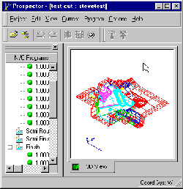
System Database
User Database
1
2
3
4
1. PowerSource User Database & System Database are combined to define the system of rules for Prospector to use.

2. The PowerSource system extracts the rules defined for the current configuration from the database.

3. At run time, PowerSource executes the rules. The results of this execution are continually used as input to Prospector to define settings and make machining recommendations.

4. Prospector continually provides PowerSource with updated information such as changes to the remaining stock, window information, etc. The updated information is processed by the rules to make the correct decisions based on the current situation.

Prospector PowerSource Applications

 | 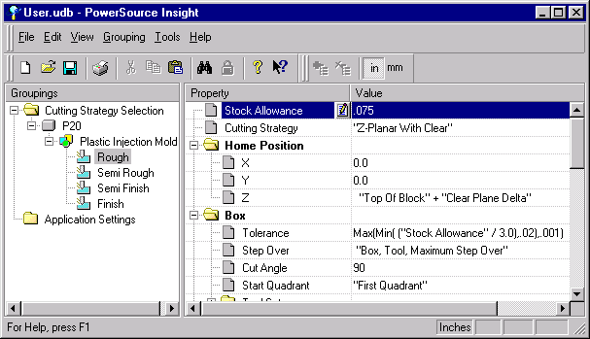
PowerSource Insight - Create, edit and save configurations and rules in the PowerSource database.

 | 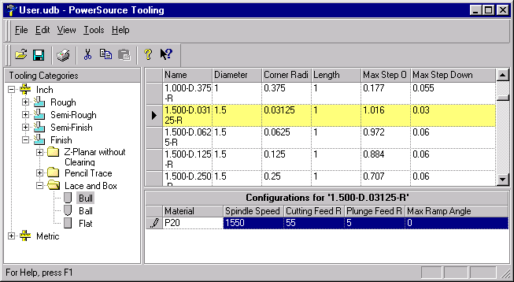
PowerSource Tooling – Create, edit and save tooling information in the PowerSource database.

PowerSource Databases

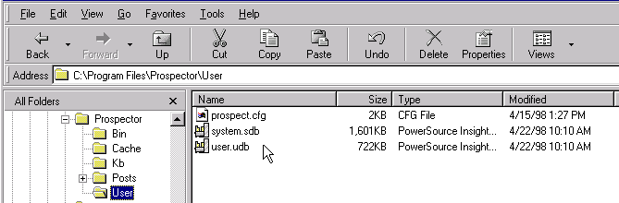
Database Files
- System Database
system.sdb in the Prospector\User directory.
- User Database
user.udb in the Prospector\User directory.
- Binary files – use PowerSource Insight to edit.
- Contains both configurations and tooling data for inch and metric

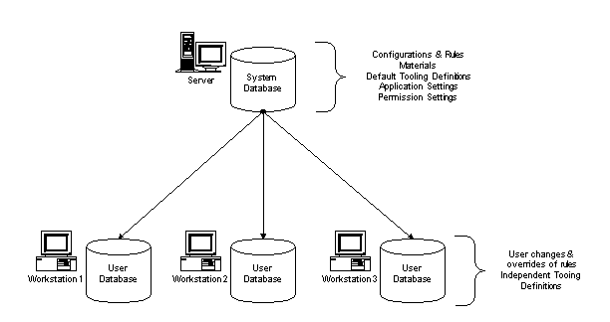

PowerSource Databases

System Database
- Master database. All user databases are derived from a system database and inherit the settings, rules and tooling from the system database.
- Allows the definition of new materials.
- Allows the definition of new configurations.
- Requires Windows NT Administrator privileges to edit.
- Permits locking of rules or settings to prevent over-ride by either the user database or from within Prospector.

User Database
- Derived from a specified system database.
- Allows editing of settings and rules not locked in the system database.
- Customize as needed to address:
- Specific user preferences
- Machine tool limitations
- Tooling requirements
- Special circumstances

Configurations

Configuration: A discrete set of rules within the PowerSource database that represent a user defined application of PowerSource.

- Any number of configurations may be created and stored in the PowerSource database

- Each Configuration has
- A Name
- An associated material type
- A set of rules for each machining stage (Rough, Semi-Rough, Semi-Finish, Finish)

For Example:
Name: Electrode
Material: Graphite
Rule Set: Rough – Z-Planar with clear,
Stock allowance = .015
Semi Rough –
Semi Finish – Z-Planar no clear
Finish – Z-Planar no clear,
Tolerance =.0002,
Gouge Detection = .001

Some other examples of configurations:
- Plastic Injection Mold
- Aluminum Prototype
- Wood Model
- High Speed Finishing
- Dies

Configurations

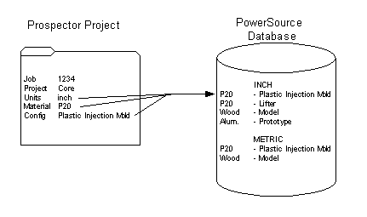

- Every project must references a PowerSource configuration

- A project contains a units identifier, material name and a configuration name

- This information provides the link to which configuration (set of rules) is appropriate for this project

Exploring the Insight User Interface

File
New – create a new user or system database.
Open – open either a system or user database for editing.
Save – save the database currently being worked on.
Print/Print Preview/Print Setup – print a database.
Exit

Edit
Cut – cuts the current selection to the clipboard.
Copy – copies the current selection to the clipboard.
Paste – pastes the clipboard into the current cell.
Find – finds a specific setting in the database.
Find Next – repeat the last Find operation.

View
Inch Rules/Metric Rules – Select the system of units to view. Every database contains separate rules and settings for inch and metric units. When Prospector runs, it will request the rules for the system of units the project was created with (i.e. you can not use inch rules with a metric project).

Advanced Mode – display fully qualified names of variables. This is useful only for power-users who intend to write advanced VB Script functions.

Status Bar – enable or disable the status bar at the bottom of the window.

Configuration
Add – create a new configuration. Note that this is disabled when editing user databases. Only when editing system databases can you create a new configuration.

Delete – delete a configuration. Again, this is a function that can only be performed when system databases are being edited.

Exploring the Insight User Interface

Tools
Permissions – lock properties in the system database. Properties that are locked in the system database can not be modified in a user database.

Customize - Tailor the user interface of Insight to best suit your needs.

Help
Help Topic – bring up the Insight help viewer.

What’s This? Shift-F1 – invokes what’s this style help. Click once, then point to an item on the screen to get more information about that item.

Exploring the Insight User Interface

On-line Help Manual

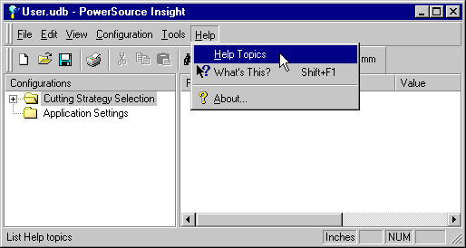
Selecting “Help Topics” will bring up the on-line help manual

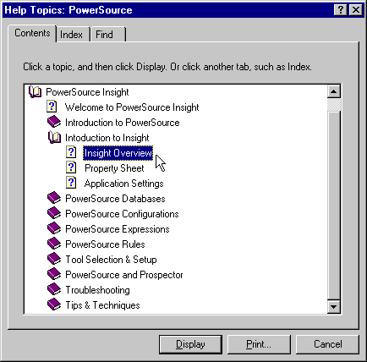
You can read through the chapters in “Contents”, peruse the “Index” for a particular topic or search for a keyword in “Find”

Exploring the Insight User Interface

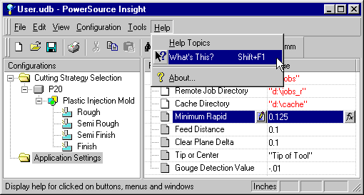
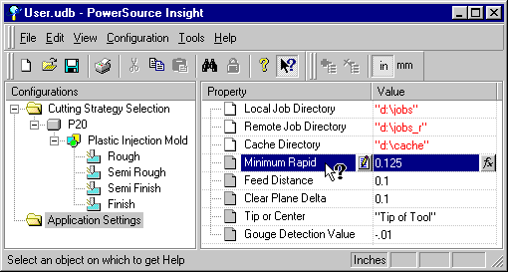
“What’s This?” Help
Selecting “What’s This?” will change the cursor. Now select item you need more information about
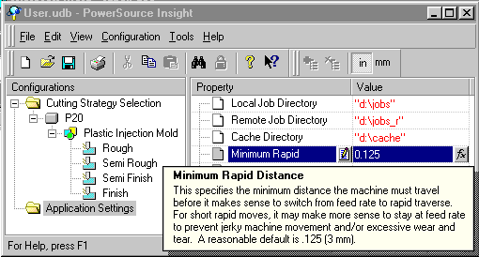
A pop-up note appears with additional information about the selected item

Introduction to Insight

Cutting Strategy Selection folder contains material definitions and configurations
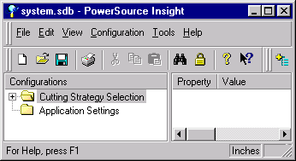
Application Settings folder contains global settings

These are the Properties for Application Settings.
These are the default values assigned to each Property shown to the left.
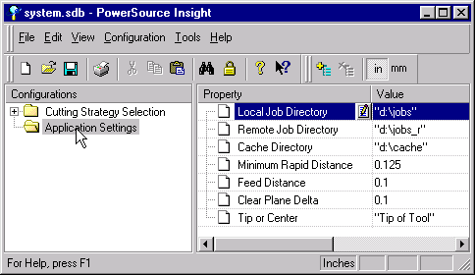
Exploring Application Settings

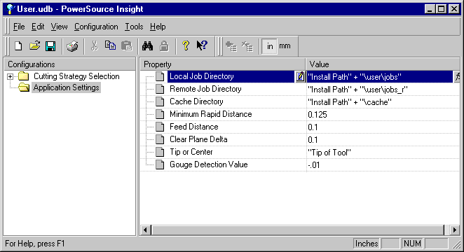

- System wide properties
- Not configuration specific – Applies to all projects
- Separate Inch and Metric properties

Exploring Configurations Tree

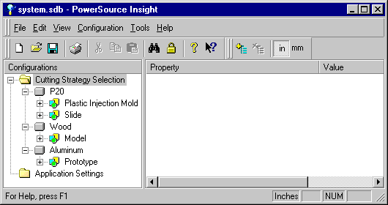

- Three materials are shown: P20, Wood & Aluminum
- Configurations are shown under each material
- P20 has two configurations: Plastic Injection Mold & Slide

- Additional materials and configurations can be created to suit most any need

Exploring Configurations Tree

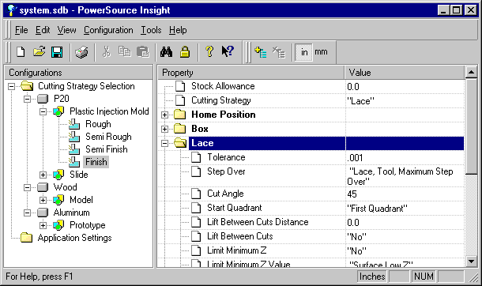

- Under each configuration are the 4 machining stages that are standard in Prospector
- Each machining stage has the same list of properties but with different values to reflect the requirements of each stage
- Rules and settings for each machining stage are defined separately. This makes sense – you wouldn’t want to use the same rules for Roughing as you would for Finish machining

- The property sheet displayed above shows the rules for machining the finishing stage of a P20 Plastic Injection Mold
- At this level in the tree you are able to create and modify rules
- Rules you create here are separate from the other machining stages and other configurations

- Separate inch and metric properties

PowerSource Properties

Property: An individual element of PowerSource that can be assigned a value.

For Example:
Some properties of a car…

Color | Red
Top Speed | 185
Manufacturer | Ford
Number of Doors | 2
Owner’s Name | “John Doe”

There are 3 types of properties in PowerSource

- String

- Numeric

- Choice List

Assigning a String Value to a Property

Step1  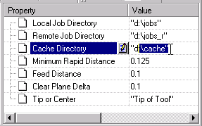  Click on the Value field. You will get the ‘I’ beam cursor. You can select (click and drag) and use Cut/Copy/Paste, type characters, use the backspace key, ....... | Step 2  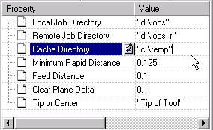  Type in your new value. Simple right? Did you forget the double quotes?

- Anytime you see a value enclosed in double quotes AND there is no drop-down box to select a value, the Property to receive that value is of type string.

- A string type is a series of characters.

- When you enter a value for a string type, it MUST BE ENCLOSED IN DOUBLE QUOTES:

Right | Wrong!
“c:\jobs\” | c:\jobs
“c:\cache” | ‘c:\cache’
“d:\Remote Job Directory” | (d:\Remote Job Directory)

Assigning a Numeric Value to a Property

Step1  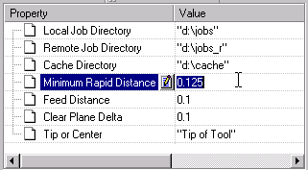  Click on the Value field. You will get the ‘I’ beam cursor. You can select (click and drag) and use Cut/Copy/Paste, type characters, use the backspace key, ....... | Step 2  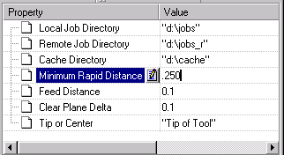  Type in your new value. This is simple – enter a number!

- Numeric types require a number to be assigned to the property. A number can be:
Whole Number: 6
Fractional: 6.5
Zero: 0
Negative: -2.3

- Do not use quotes

Right | Wrong!
18.2 | “18.2”
-5 | ‘-5’
0.0 | ()

Assigning a Choice List value to a Property

Step1  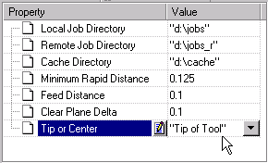  Click on the Value field. If you see a drop-down list, this property is a Choice List type.... | Step 2  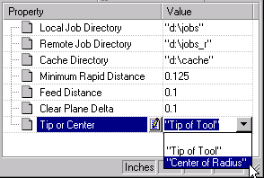  Select the proper value for the property from the drop-down list.

- If a property value offers a drop-down list, it is a choice list type and requires a selection from the drop-down list.

- Only a single selection from the drop-down list allowed.

Lab Exercise # 1

Setting Properties

Exercise A

Set the Minimum Rapid Distance in Application Settings to be 0.2 inches. Set the metric value to 5mm.

Exercise B

When doing Lace finishing on a P20 Plastic Injection Mold set the default cutting angle to 90 degrees. Do this for both inch and metric.

Exercise C

When doing Z-Planar with Clear Roughing on a P20 Plastic Injection Mold set the default clearing style to use Zig-Zag Clearing. Do this for both inch and metric.

Exercise D

Set the default cache directory to be the temp directory on the C Drive. Do this for both inch and metric.

System Database

Creating a new Configuration

You may only create and delete configurations from within a system database.

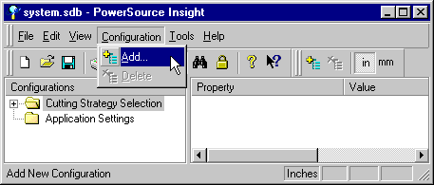
To create new configurations select the Add Configuration menu item. This brings up the New Configurations dialog.

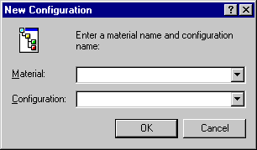

Type in new names or select from the drop down list
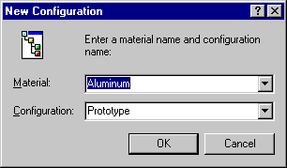

System Database

Creating a new Configuration

- You may only create configurations from within a system database
- A new configuration starts off being completely empty
- You should provide a default value for all properties in your new configuration. Insight will warn you when you exit if not all properties have default values
- The new configuration is created only in the system of units you are currently working in

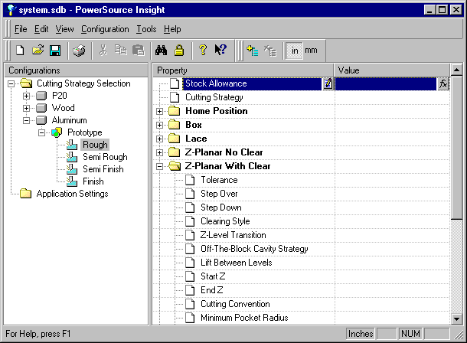
A new configuration starts off empty. You must fill in default values for each property

System Database

Creating a new Configuration
- Instead of creating a new configuration from scratch use Copy & Paste to avoid having to enter all those default values
- Use Copy & Paste to clone an existing configuration
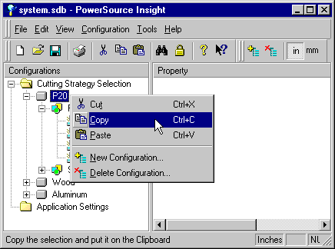
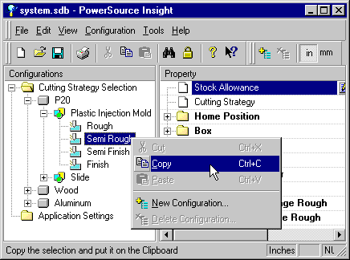
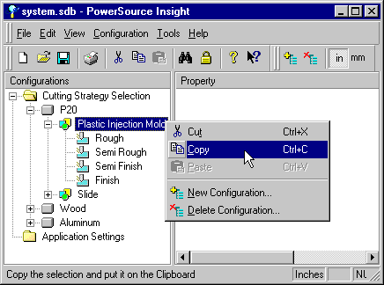
- Copy any Material, Configuration or Machining Stage
Copy a material
Copy a configuration
Copy a machining stage

System Database

Creating a new Configuration
- Paste the copied selection
- Paste one ‘level’ above where you did the copy

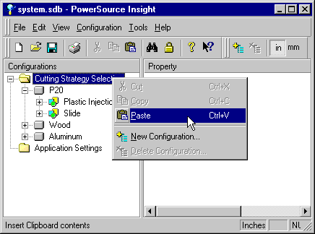
When you copy a material, select the “Cutting Strategy Selection” folder to past the new material with the others

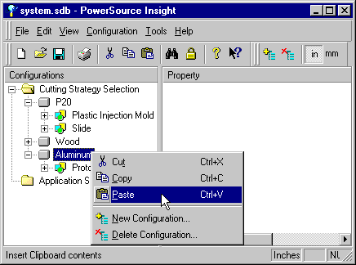
When you copy a configuration, select a material folder to paste the new configuration under that material

System Database

Deleting a Configuration

- Always make a backup copy of your System and User databases before you delete configurations
- Be very careful. Deleting a configuration will also:
- Delete any user overrides for that configuration in any User databases created from this system database
- Delete any tooling configuration setup based off of a material that you delete
- Deleting a configuration will only delete it in the system of units you are currently working in

When you delete configurations, the next time you open a user database you will see this informational message:
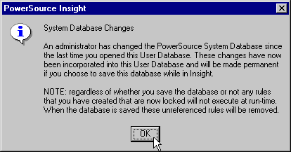
This is a warning that someone has modified the system database since the last time you opened your user database.

The administrator may have deleted a configuration in which you have created rules that you don’t want lost. For safety reasons, it’s best to first make a backup copy of your user database before saving.

Property Permissions

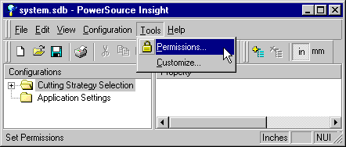
Selecting the “Permissions” menu item brings up the Permissions dialog. Lock properties from being changed in user databases.

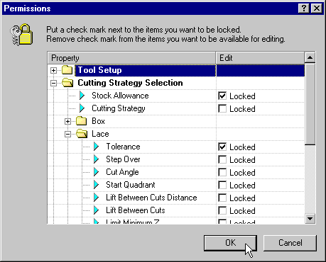
- A locked property can not be modified in any user databases created from this system database
- Locking a property locks it for all configurations, all machining stages and both systems of units

Lab Exercise #2

Configurations & Permissions

Exercise A

Open the system database and create the following new configurations:
Metric - P20 – Slide
Inch - Aluminum – Prototype

Use Copy/Paste to duplicate the Inch – P20 – Plastic Injection Mold configuration to make the Inch – P20 – Mold Cavity configuration.

Use Copy/Paste to duplicate the metric - P20 material for metric - Wood

Exercise B

Open the system database and lock Tolerance and Stock Allowance for all settings in P20 – Plastic Injection Mold for inch.

Open the user database and verify that the property is indeed locked and cannot be changed.

Prospector and PowerSource

Selecting which user database to use within Prospector

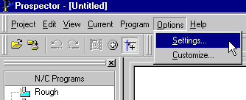
Options/Settings brings up a dialog that lets you choose which PowerSource user database to use

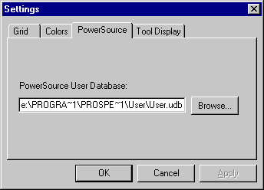

- This setting is saved for each individual NT Workstation user login
- Each time a user logs in and runs Prospector he will be using the same database unless it is changed using this settings dialog
- Each user login could point to the same or different databases

- You do not need to exit or re-start Prospector when you change databases
- The database selected here is used for ALL projects including new projects created and old ones opened

- 2 users who share a workstation and share a login ID will have to also share a user database (The alternative is having to always go to this dialog and change the desired user database each time)

Prospector and PowerSource

Specifying a configuration for a Project

When you create a new project you must also specify a configuration within your current PowerSource database to associate with this project:

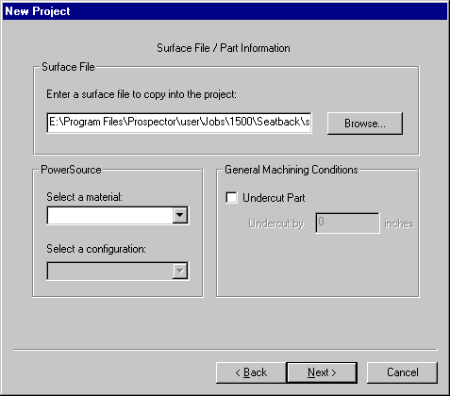
Select from the drop down lists a material type and configuration.

The drop down lists contains those materials and configurations found in your current PowerSource database.

- From now on each time you open this project it will look in your current PowerSource database for this configuration
- The rules defined within this configuration are used to guide Prospectors execution while this project is open
- The next time you open this project, if the necessary configuration does not exist you will be prompted to select a new one. This would occur if an administrator deleted the configuration or you are opening and old project not yet associated with a configuration

Prospector and PowerSource

The New Program Wizard’s last page

The last page of the new program wizard shows a property tree very similar to what is shown in Insight

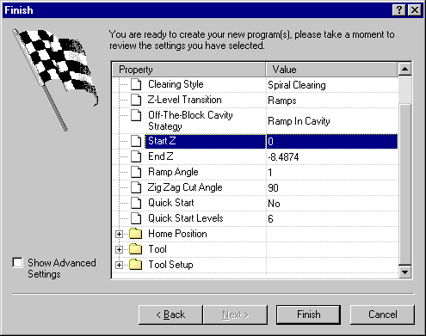

- The last page will show all properties and their values that will be used in the creation of that program
- Property values may be changed here provided they are not locked by the System Database
- Checking the Advanced Settings box will show all properties not just those that appear in the new program wizard

Prospector and PowerSource

Demonstration of Prospector’s use of PowerSource
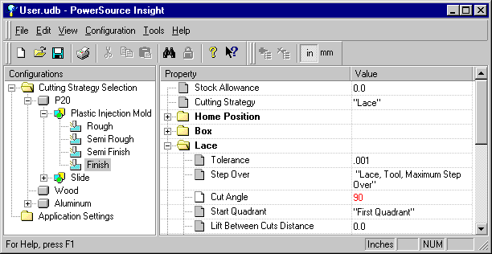
When doing Finish of a P20 Plastic Injection Mold we want a stock allowance of 0.0 and a cutting strategy of Lace.

When doing Finish Lace cutting we change the cut angle to be 90 degrees.

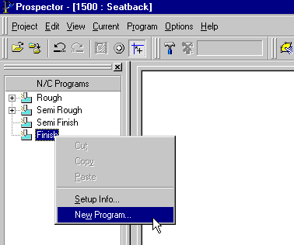
Select New Program in the Finish machining stage

Prospector and PowerSource

Demonstration of Prospector’s use of PowerSource

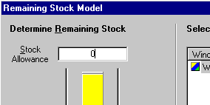
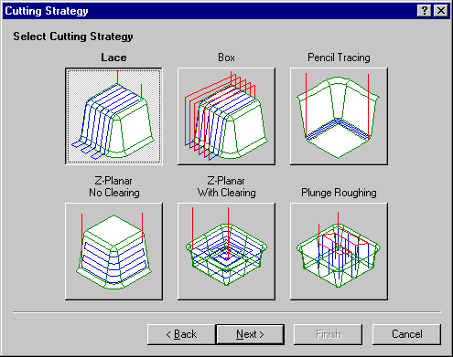
Stock Allowance set to 0.0 as desired and Lace is chosen as the cutting strategy
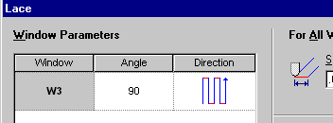
… And the cutting angle defaults to 90 as desired

Prospector and PowerSource

Demonstration of Permission settings in effect

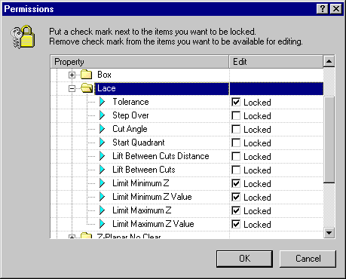

- In Insight we edit the System Database and lock a number of properties for Lace machining as shown above

Prospector and PowerSource

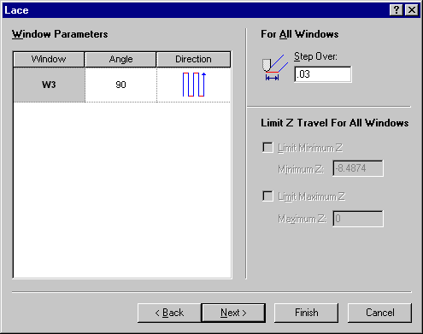
Demonstration of Permission settings in effect
The Limit-Z options are shown locked in the New Program Wizard
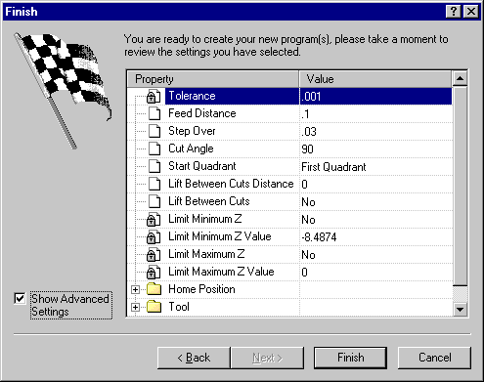
On the last page of the wizard notice the lock icon indicating which properties can not be changed

Lab Exercise #3

Prospector and PowerSource

Exercise A

Start Prospector and look in the Options/Settings dialog to verify which user database you are using.

Exercise B

Create a new project within Prospector. Assign the project a material of “P20” and a configuration of “Plastic Injection Mold”.

Open the user database within Insight and modify these properties for Inch, P20, Plastic Injection Mold, Finish Machining:
Cutting Strategy = Box
Stock Allowance = .001
Box Start Quadrant = “Second Quadrant”

Verify these changes while running Prospector.

Exercise C

Within Insight for Box machining lock the following properties for all machining stages:
Stock Allowance
Cutting Strategy
Cut Angle

Verify the locks in Prospector.

PowerSource Database Setup

After Prospector is installed a careful examination of how you plan to implement System and User databases will pay many dividends down the road.

Implementation of PowerSource databases requires an up-front analysis of your shop. Here are some questions to ask yourself:

- What materials are used throughout the shop?
- What types of parts – applications – are manufactured? Also consider differences in what appears to be similar parts. For example, the B-side of a mold may not need to be machined to the exacting tolerances of the A-side. A lifter might generally fit into a category of parts that is typically finished using Z-Planar instead of lace machining. Identify categories of parts which will likely need different rules and methods for machining.
- What shop-wide rules do you have to help eliminate errors?
- What types of machine tools are used? Do any have restrictions or special requirements?
- Are specific machine(s) used for specific operations? For example, do you have a roughing machine? High speed finishing machine?
- Do individual machinists have certain preferences for machining?
- What are the tooling needs for each application?

Design your database implementation such that as many common and shop-wide configurations are self-contained in a central system database.

User databases will contain only necessary changes to the system database to adapt the Prospector seat to the situation.

Think of the system database as a master database that generalizes everything that is done in the shop. At the highest level, capture as much of this information as possible and place it in the system database. The user databases will contain only the needed variances from the system database to reflect situational needs.

PowerSource Database Setup

Sifting Data into System and User Databases

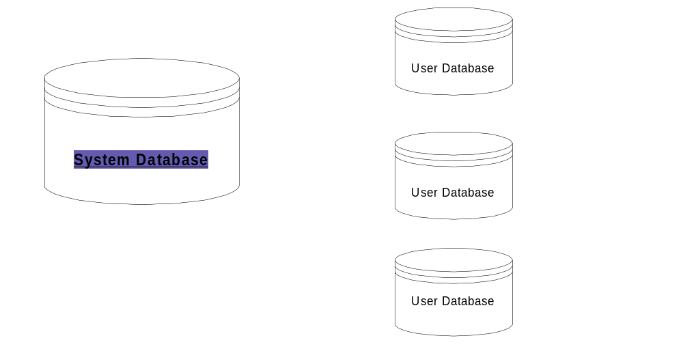System Database - Generalized | User Database - Situational
All materials used in the shop for all different parts (wood, aluminum, P20 tool steel, …) | Customized settings for specific machine tool to adapt to its limitations or enhanced capabilities (old roughing machine doesn’t hold tolerances well so program larger stock allowance automatically).
All parts manufactured (mold cavities, electrodes, …) | Custom settings for individual machinist preferences. Joe on night shift prefers off-the-block Z-Level while Bob on day shift always ramps in material. Both methods are sound machining practices.
Shop rules – make sure everyone is doing certain things in a consistent high-quality manner (always setup tip of tool, Z-home positions always set to clear the work by a safe margin, tolerances for finish machining,…) | Forced to follow the conventions applied in the system database.
“Starter set” of tooling with configurations for all defined materials. | Customized tooling and tool configurations (lower feed rates, step-over, step-down for low-horsepower machines; higher feed rates, spindle speeds for high speed finishing machines).
Common sense rules for each configuration (don’t ever use coolant when cutting wood or electrodes). | Customized machining practices for specialized tooling (conventional cut when doing Z-Planar electrodes).

Getting Started on a System Database

Write down all the materials used in the shop. Next write down the different part types (configurations) that will be needed for each material type. Now you’re ready to begin building a system database following these simple steps:

- Create your materials.
- For each material you created, add the needed configurations. Remember that each configuration need not appear under each material type. For example, you wouldn’t consider making a wood electrode!
- For each configuration you developed in Step 2, program the rules needed for that category. The best approach is to start with one configuration, completely program it then copy it to the other configurations making changes only in those areas that changes are needed.
- In PowerSource Tooling, seed the system database with a common set of tools. Don’t forget to add reasonable configurations for each tool. It probably doesn’t make sense to try to program everyone’s tools and configurations in the system database. It’s a better approach to seed it with a good “starter set” of tools from which the individual user databases can begin customization for their own needs.

Database Implementation in the Shop

Make your life simple – create 1 system database from which all user databases are created. Why?
- User databases are bound to system databases permanently.
- Making a change to the system database automatically propagates to the user databases so everyone benefits from changes and enhancements.
- System administration is easy – changes and enhancements are made in one place.
- Keep control of the database scheme and shop rule enforcement.

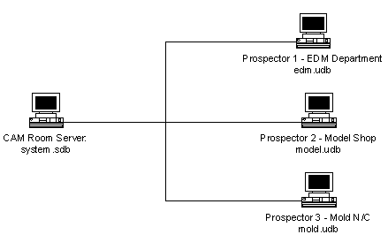
Typical Shop Implementation – System Database in the CAM room serving 3 clients in the shop – each with their own custom user databases.

Creating User Databases

The first step in creating a user database is to specify which system database the new user database will be created from. This becomes the user databases’ parent database.

Select File/New:
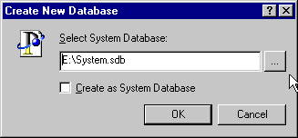
Once you select the system database, the following will happen:
- All tooling definitions from the system database will be imported into the user database being developed. This is a one-time event! Any changes to the tooling definitions in the system database will never again be exported to the client user databases.
- Once the user database is created, it is forever married to the system database. Unlike real-life, this software marriage is forever. You can never again point the user database to a different system database – it knows who it’s original partner was and will refuse all others. So backup of the system database is critical! If you lose it due to hardware failure, you will have to start all over again creating your system of rules.
- The user database is created with the same rules as the system database specified but does not duplicate the data. What really happens is anytime the user database is opened, it automatically constructs itself by first loading the rules and expressions from the system database then adding only those changes programmed into the user database.

Creating User Databases

- If you need to relocate the system database to a different server workstation, the client workstations will still function. When you start Prospector, it will inform you that it can no longer find the system database and ask you to Browse for it.

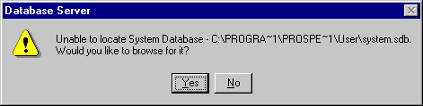
Click Yes and the standard Windows File/Open dialog will be presented to allow you to select a new network drive and directory where the system database is located.

Once you re-connect to the new location of the system database, Prospector will remember its new location permanently.

- While you are editing a database in Insight, no one else can access the database. Insight automatically creates a database lock file in that directory:

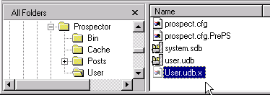
The file User.udb.x is a lock file. This prevents concurrent access to the database being edited – User.udb. If the system should crash this file will have to be removed manually before you can edit the database User.udb again. The file System.udb.x serves the same purpose for system databases.

PowerSource Tooling

Tooling Categories Tree
Control – Selects Inch/Metric tooling, machining stage, machining strategy and cutter type.
Tool Description Grid Create new tools, edit existing tools or delete tools.
Tool Configuration Grid
Apply proper speed, feed rate and ramp angle for a tool selected in the Tool Description Grid for each material type defined in the database.

PowerSource Tooling

Drilling Down for Tools

Pick Inch or Metric Tools... | Pick a Machining Stage...
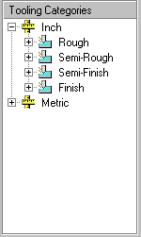 | 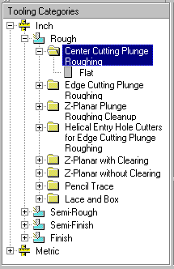
Open Inch Tooling.... | Open Rough Stage

PowerSource Tooling

Drilling Down for Tools

Pick a Machining Strategy
Open Center Cutting Plunge Roughing machining strategy...

PowerSource Tooling

Drilling Down for Tools

Display Tools of a Particular Shape

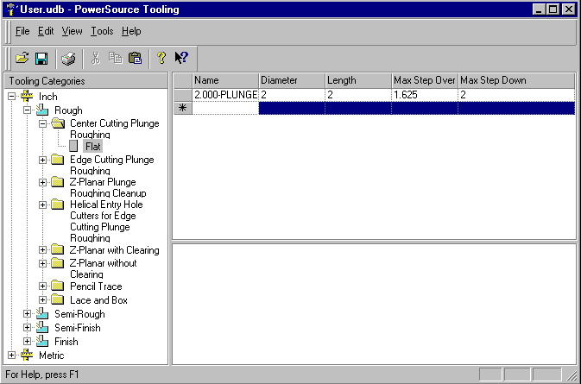
Double Click on Flat to display all the tools used for roughing when using center cutting plunge rough machining. Note that only Flat shows up in this example because no other tool shapes are defined for this operation.

PowerSource Tooling

Add a New Tool Definition

Adding a tool definition:

Open the user database to add the tooling.
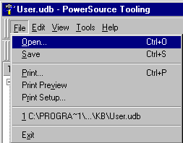 | 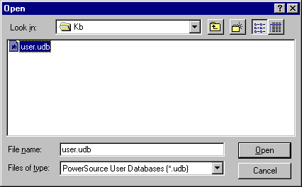

Using the tree control, drill-down to the system of units, category and machining operation that you are creating the tool for. In this example, we’ll add an inch ball cutter for use with lace and box style cutting for finishing operations.
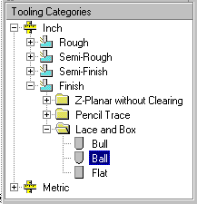

PowerSource Tooling

Add a New Tool Definition

Use the tree to drill-down to Inch tooling, Finishing, Lace and Box machining, Ball tools.

Click on the Ball icon to cause the display of all tools for this operation to be shown in the window to the right of the tree control.
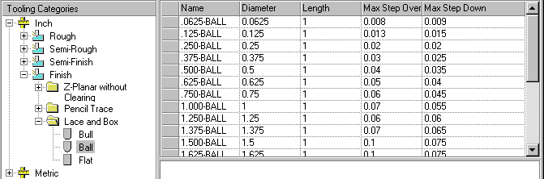
These are all the inch ball tools for finish machining for lace & box style strategies.

Click on the row marked with a * to begin to add a new tool:
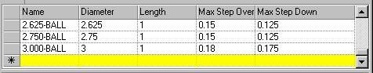
Click on the * to begin adding a new tool.

Click in the column labeled Name to begin filling in the tool parameters. Note that when you click in this column, it automatically fills in with the data from the tool described immediately preceding this definition.

PowerSource Tooling

Add a New Tool Definition

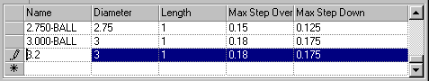
Begin filling in the fields for the new tool.

As you complete each field, click in the column to fill it in or use the tab key.

Once you have completed entering the parameters for the tool, the next step is adding a configuration for the tool.

PowerSource Tooling

Tool Configurations

- A tool configuration defines parameters to be used with a particular tool based on the material type.

- Whenever you add a new tool or edit an existing tool, the Configuration window opens automatically to display the tool configuration data:
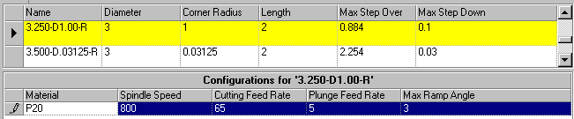
Configuration for 3.25 X 1.00 Bull Tool

- Each line in the configuration window shows the parameters to be used for the tool with a particular material. In the example above, a single configuration for P20 tool steel is shown.

PowerSource Tooling

Adding a New Tool Configuration

To add a new tool configuration, follow these simple steps:

Click on the row with the * symbol:
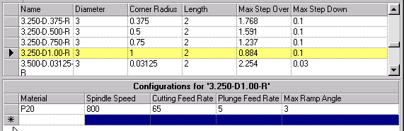

Click the * to begin a new configuration.

From the drop-down box in column 1 – Material - select the material type for this new configuration:
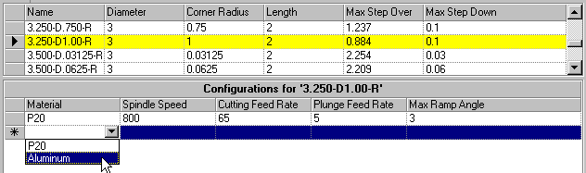
Select a Material for this new configuration – Aluminum in this case.

PowerSource Tooling

Adding a New Tool Configuration

Complete the configuration filling in each column of data for the configuration:
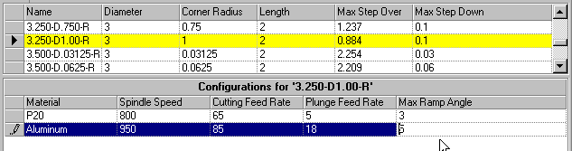
Fill in the remaining columns for this configuration.

Lab Exercise #4

PowerSource Tooling

Exercise A

Add a Ball nose tool to be used when doing Lace Finishing:

inch Ball Nose, Length = 1.0, Max Step Down = .18
Max Step Over = .19

Add a configuration for this tool to be used with P20:

Spindle Speed = 850, Cutting Feed = 65
Plunge Feed = 5, Max ramp = 3

Now run Prospector and verify the tool shows up in the New Program wizard.

PowerSource Expressions

- Examples of simple expressions

3 + 2 < Simple math expression

( 5 + 3 ) / 2 < Parentheses impart order

( 6 * ( 5 + 3 ) / 2 ) * 4

- Expressions with variables

A + 2

A + B

( B + 3 ) / A < Simple math, but we need to
know the values of A & B before
we can solve the expression

- Expressions with functions

SquareRoot( 4 ) + 2

Maximum( 5, 3 ) / 2

( Minimum( A, B ) + 3 ) / 2

- Example Prospector expression

“I would like my Minimum Pocket Radius to be 125% of the value of my Tool Diameter.”

MinimumPocketRadius = 1.25 * ToolDiameter

Lab Exercise #5

Expressions

Write an expression for the following statement:

I have a bag with X number of oranges and Y number of apples. If I were to eat half of the fruit in the bag, how many would that be?

Number to eat = ________________________________________

Write an expression for the following statement:

Given that I have X oranges and Y apples I want to eat half of the oranges OR apples whichever one there is more of.

Number to eat = ________________________________________

Write an expression for the following statement:

Given that I have X oranges and Y apples I want to eat half of the oranges OR apples whichever one there is more of. But regardless, I want to make sure I eat at least 2 piece of fruit.

Number to eat = ________________________________________

Insight Expression Builder

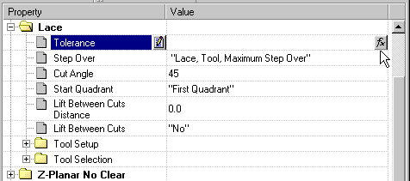
To start creating an expression press the Expression Builder button
Create expressions wherever numeric values are allowed

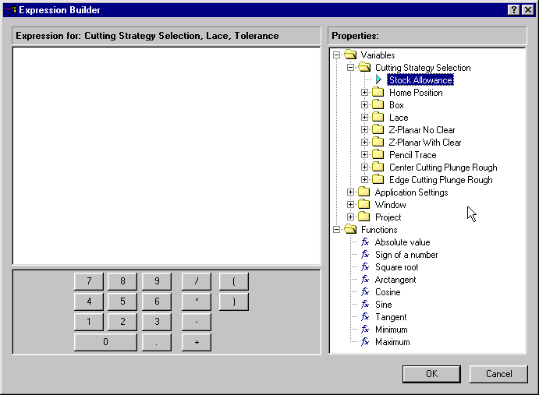
Edit Pane where expressions are formed and edited
Calculator style keypad
Tree of PowerSource Properties (Variables & Functions)

Insight Expression Builder

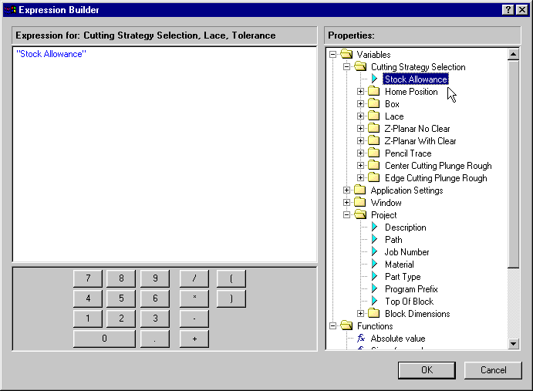
Double clicking on a property will add it to the Edit Pane

- Navigate the property tree to find the desired property
- Use “What’s This” help for information on each property
- Double click to insert the property into the edit pane

Insight Expression Builder

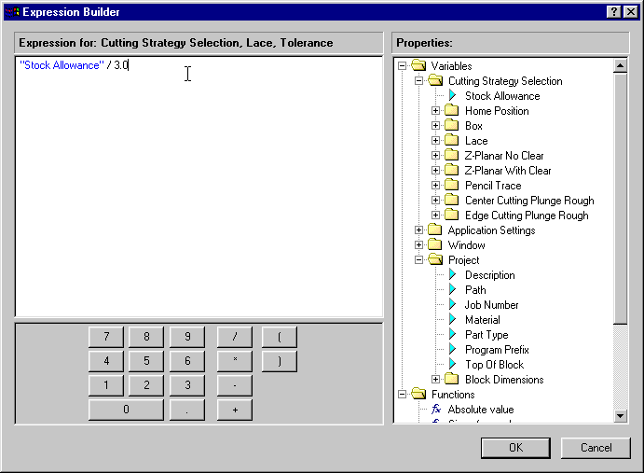
Type in the rest of the expression.

Properties appear in blue and your typed in text appears in black.

Select OK to save the expression

- Properties must have quotes around them
- Recognized properties are shown in blue text
- The edit pane works like other editors – Place insertion cursor at desired point and type. Backspace key to delete
- When you are done select OK to save the expression

Insight Expression Builder

Your completed expression is shown when you return to Insight’s property tree

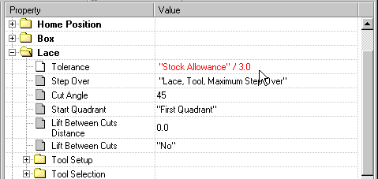
Red signifies that you’ve changed the default provided by the System Database

- Looking for red values in the property tree provides an easy way to see what you’ve changed
- You can get back to the default value by simply clearing out (backspacing over) the red value and hitting return

Insight Expression Builder

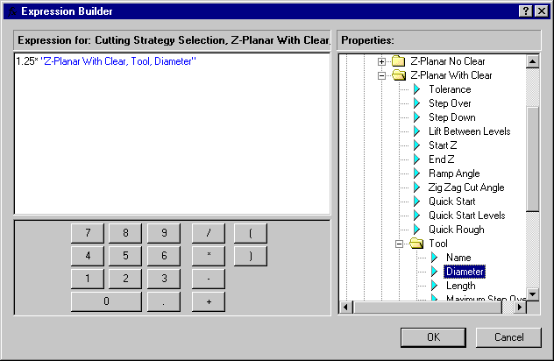
Note how property names contain commas and reflect their location within the property tree

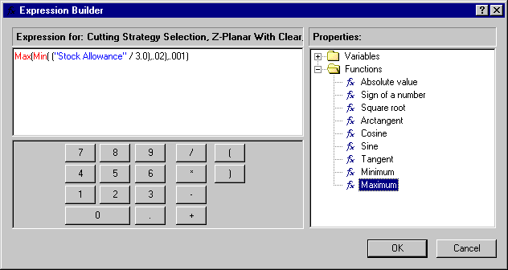
Note the use of functions here.

Functions are highlighted in red.
This is a more complex expression.

The Max and Min functions are used to bound the resulting value to a valid range.

It says to use 1/3 of the Stock Allowance but make sure it’s at least .001 and no more than .02.

Insight Expression Builder

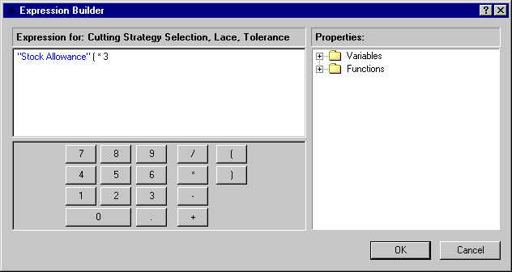
This is not a valid expression. It has extra parentheses.

This is an example of a Syntax Error.

Insight will automatically check for syntax errors when you press OK.

If an error is found it displays a warning.

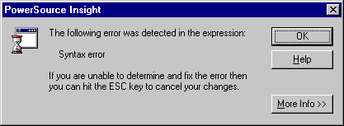

- All expressions must follow the syntax rules for VBScript
- Insight checks for syntax errors automatically when you create the expression
- You must fix any syntax error before Insight will allow you to continue
- You should always test your new expressions in Prospector

Lab Exercise #6

Expression Builder

For each of the following exercise use PowerSource Insight to modify your user database to solve the described problems. Use Prospector to verify the expression works as desired.

Exercise A

Whenever I use Prospector I always want my home position to automatically default to 2 inches above the top of block in Z.

Exercise B

Whenever I’m doing finishing and using Pencil Trace I would like the number of ribs to be automatically set for me. The number of ribs should be the maximum amount of stock left in the window divided by the step down used for Pencil Trace.

Exercise C

When I am doing finishing and using lace cuts I like to lift between cuts. The distance that it lifts should always be 50% of the current stock allowance.

Exercise D

Whenever I use Prospector I always want the X & Y of my home position to automatically default to being the location of the center of my window.

PowerSource Rules

A PowerSource Rule allows you to specify multiple expressions for one property and also specify under which condition each expression should be used.

Rules are built using conditional statements like these examples:

IF “I’m Cold”
THEN “Put Jacket On”
ELSE “Take Jacket Off”

IF “I’m Cold” AND “I’m Outside”
THEN “Put Jacket On”
ELSE IF “I’m Cold” AND “I’m Inside”
THEN “Put Blanket On”
ELSE “Don’t Put Anything Extra On”

IF “Tool’s Maximum Ramp Angle” > 0
THEN “Z-Level Transition” = RAMPS
ELSE “Z-Level Transition” = OFF_THE_BLOCK

Lab Exercise #7

Rules

Write a rule for the following statement:

On days when the weather is rainy or days when the temperature is less than 50 degrees I’d rather stay in and play chess otherwise I’d go outside and play basketball.

Write a rule for the following statement:

When I’m doing semi-finish cuts the cutting strategy I’d use would be Z-Planar with clearing only if the amount of stock is greater than 1 inch. Otherwise, I’d choose to use a Z-Planar without clearing cutting strategy.

Write a rule for the following statement:

When the temperature is less than 30° F I’ll wear a heavy jacket. When the temperature is between 30° F and 60° F I’ll wear a light jacket, otherwise I won’t wear a jacket.

Insight Rule Builder

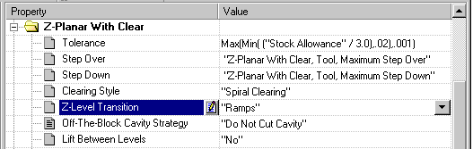
To create a rule, select the Create Rule button

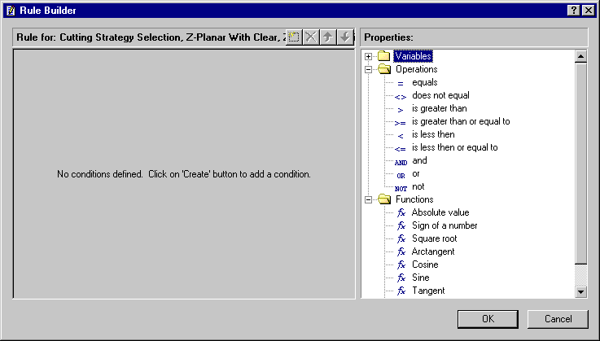
Edit pane where the rule is created
Property list similar to the expression builder but with the addition of Logical Operators
Select the Create New Condition button to add a condition to the rule

Insight Rule Builder

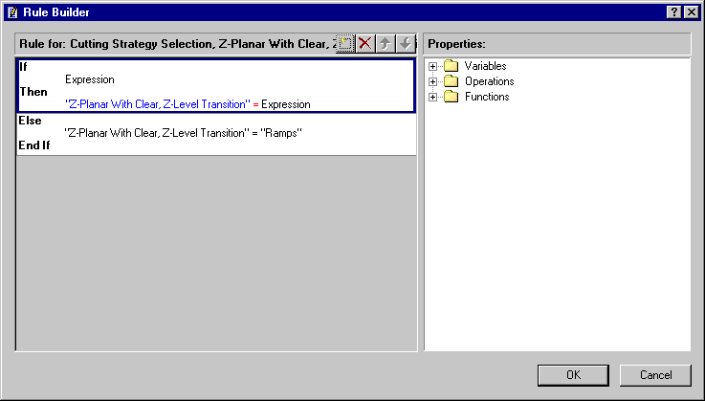
Replace the “Expression” place holders with your desired expression

- The Create Condition button creates a new IF-THEN condition statement
- You always have an ELSE-ENDIF default condition
- You replace the “Expression” place holders with your desired expressions

Insight Rule Builder

You may remove a condition or change the order. Remember conditions are evaluated from top to bottom
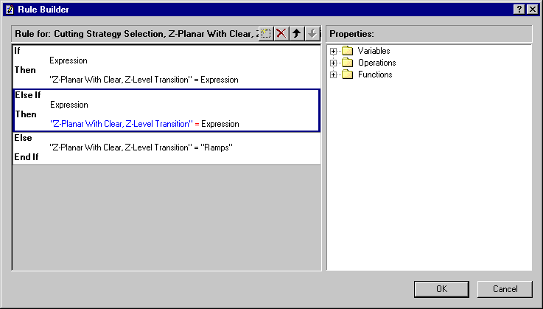
Pressing the Create Condition button inserts another condition statement

- A blue rectangle indicates which condition is active
- You can remove or change the order of the active condition
- Conditions are evaluated from the top down
- If none of the conditions are true the default condition (last one) is used

Insight Rule Builder

When doing Z-Planar with Clearing if the tool being used can ramp then ramp otherwise go off the block to get to the next level.

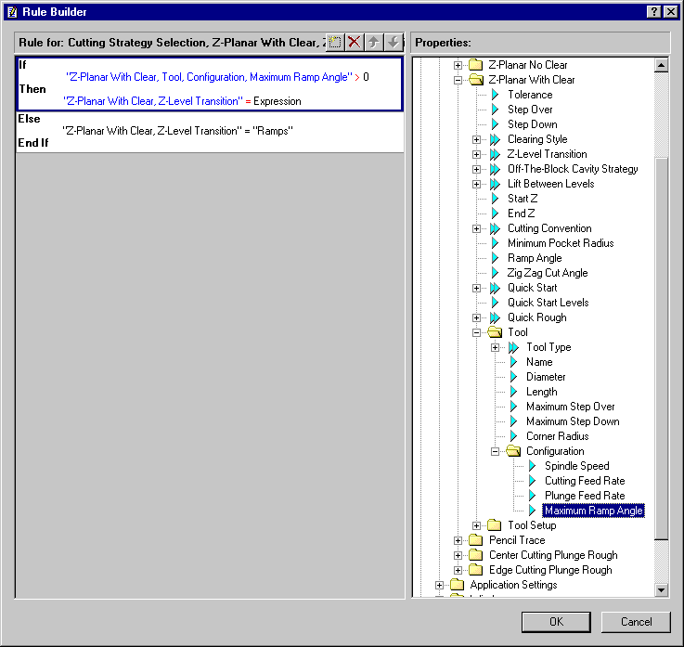
First, Specify the IF portion of the condition. Check to see if the tool’s Ramp Angle is greater than zero
Find the Property that specifies the ramp angle for the tool used when doing Z-Planar With Clear

Insight Rule Builder

When doing Z-Planar with Clearing if the tool being used can ramp then ramp otherwise go off the block to get to the next level.

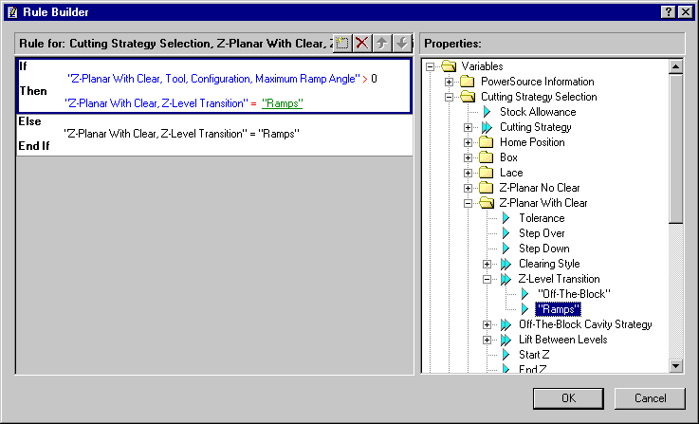
Now specify the Then portion. If the ramp angle is greater than zero Then we should ramp
Z-Level Transition is the variable we are trying to set the value to be Ramps. Find it in the property tree and see the list of available choices

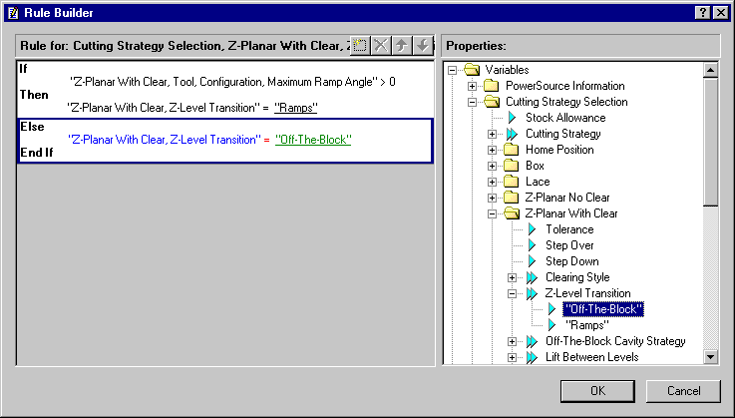
And lastly we set the default condition. If the condition for ramping is not true we should do Off the Block transitions
Select OK to save the rule. Insight will check for syntax errors

Insight Rule Builder

When doing Z-Planar with Clearing if the tool being used can ramp then ramp otherwise go off the block to get to the next level.

The rule is created. Red indicates that we’ve changed the default value supplied by the System Database
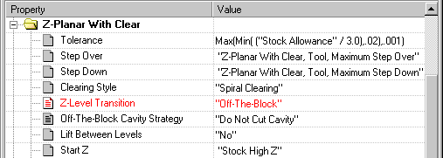
Icons with lines indicate that property has an associated rule
The value shown here is what is used in your default condition

- Remember to always test new rules in Prospector

Lab Exercise #8

Rule Builder

For this exercise use PowerSource Insight to modify your user database to solve the described problems. Use Prospector to verify each rule works as desired.

Exercise A

When doing semi-finish lace cutting I sometimes like to lift between cuts. I only do this when I know the step over of the tool is greater than .025 inches. When I do lift between cuts I like to always lift up 0.01 inches.

Exercise B

When doing my semi-finish cuts I’ll use Z-Planar with clearing if I see that the amount of stock in the window is more than 1 inch otherwise I’d choose to use Z-Planar without clearing.

Exercise C

When doing my semi-finish cuts I’ll use Z-Planar with clearing if I see that the amount of stock in the window is more than 1 inch. However if the amount of stock is less than 0.25 inches I’d choose to lace cut it, otherwise I’d use Z-Planar without clearing.

Error Types

Syntax Errors
- Insight will discover and report syntax errors during rule creation time
- The rule builder will detect syntax errors just like the expression builder
- A syntax error happens when the rule or expression does not follow correct VBScript syntax

Logic Errors
- Discovered at runtime
- Logic errors occur when you make incorrect use of PowerSource properties
- With Logic errors you’ve defined a syntactically correct rule or expression but when you run Prospector the result of your rule is not what was expected
- PowerSource is able to detect some types of logic errors and will show an error dialog at runtime
- Other types of logic errors are found “by hand” when you verify your rule in Prospector

Logic Errors

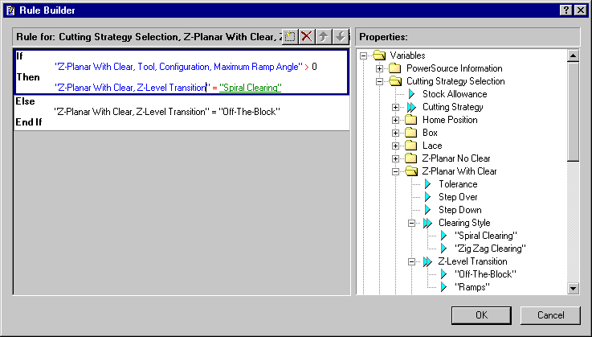
The user should have used “Ramps” here but mistakenly selected “Spiral Clearing”

- Syntactically the assignment of “Z-Level Transition = Spiral Clearing” is correct. It follows the rules of VBScript
- This is a logic error since at runtime when this rule is processed there is a good chance you won’t get “Ramps” like you intended
The tool has a ramp angle of 1 so the rule should have suggested that we “Ramp”. However, because of the logic error it chose “Off The Block”
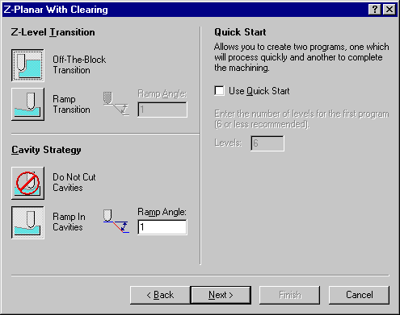

Logic Errors

PowerSource can detect some types of logic errors at runtime. A warning dialog is displayed.

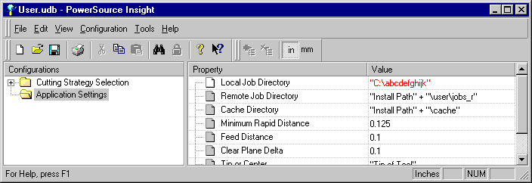
The path to the local job directory is changed to a non-existent directory

- Syntactically the assignment is correct. A valid string is assigned to the property
- Logically the string is incorrect since the path is to a directory that does not exist

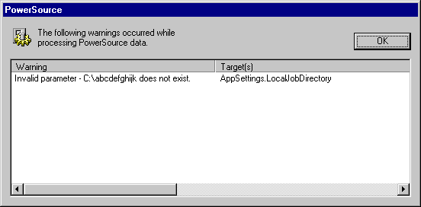

- A warning dialog is displayed when you return to Prospector
- Remember to always verify your new rules in Prospector

Debugging Techniques

- Each time you save your changes in Insight or Tooling, Prospector will re-load your database automatically
- Hitting OK on the PowerSource warning dialog will cause Prospector to continue with a safe default
- You should fix all reported warnings or errors immediately
- You can use Insight’s Find command to quickly jump to the source of an error

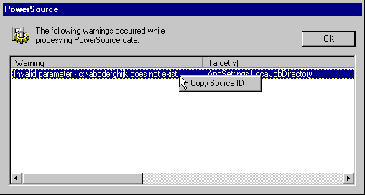
Right-Click on a warning and select Copy Source ID
This will copy the identifier of the property that caused the error to the Windows clipboard

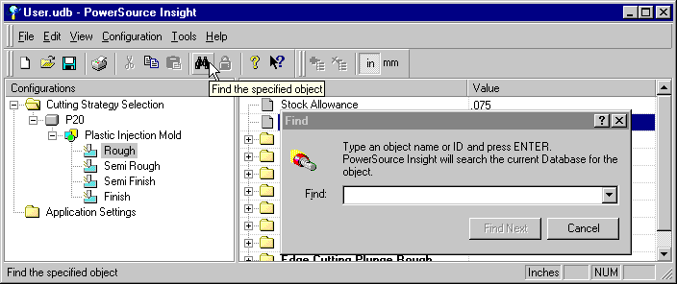
Clicking on Find in Insight brings up a Find dialog that allows you to search the database

Debugging Techniques

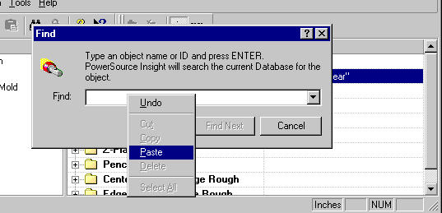
Select Paste to paste the ID in the dialog

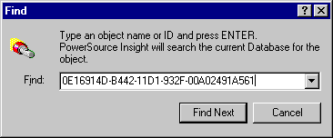
Selecting “Find Next” will highlight the related property in Insight

- The Find command is useful to locate the exact property that generated an error
- Also use Find to find all the occurrences of a the same property in all configurations

Lab Exercise #9

Debugging Errors

For this exercise use PowerSource Insight to modify your user database to solve the described problems. Use Prospector to verify each rule works as desired.

Exercise A

Change your default path of your remote job directory to point to a non-existent directory. Now re-run Prospector.

Use the information from the error dialog to locate the source of the error within Insight.

Insight Tooling Information

When building rules and expressions you may require some information about the tool. Tooling information is organized into two groupings:
- Tool
- Tool Setup

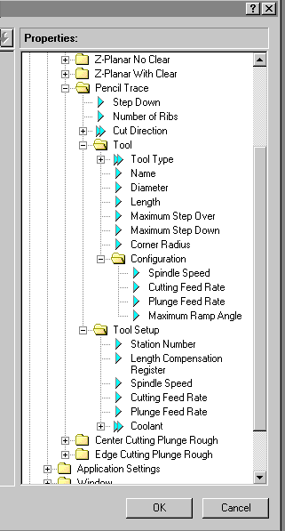
The “Tool” folder contains properties for the tool used. The sub-folder “Configuration” contains properties for the tool including feed and speed information.

These properties map directly to the tooling database.

The “Tool Setup” folder references properties to be used for the tool selected.

Insight Tooling Information

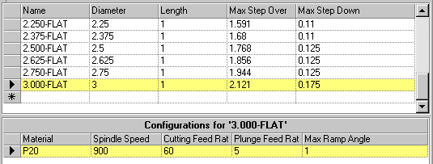 | 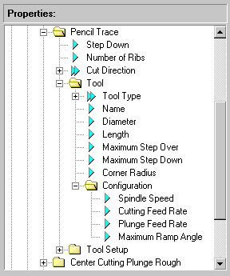
Data in the Select Tool tree control on Page 3 of the Program/New Wizard – Tool Selection – corresponds to…. | The properties under the Tool folder and Configuration sub-folder in the Insight properties tree.

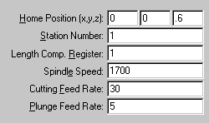 | 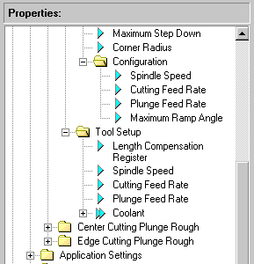
Data in the Tool Details on Page 3 of the Program/New Wizard – Tool Selection – corresponds to…. | The properties under Tool Setup.

Insight Tooling Information

- These 3 properties - Spindle Speed, Cutting Feed Rate and Plunge Feed Rate - appear in folder for Configuration and Tool Setup.

- Configuration refers to the speeds and feeds of a tool in the Tooling Database

- Tool Setup refers to the speeds and feeds input on Page 3 of the Program/New wizard.

Use the properties from the Configuration when formulating a rule where you wish to use data from the tooling database. For example, set the default spindle speed for lace finishing an aluminum prototype mold to the 120% of the spindle speed for the tool selected from the tooling database.

Use the properties from Tool Setup when formulating a rule based on the input value from the user on the tooling page. For example, you would use this value to construct a rule that will never permit more than 125% of the maximum plunge feed rate for a tool to be used. If the user entered an excessive value, PowerSource would automatically reduce it to the lower, safer value.

Insight Tooling Information

In Insight, there are 2 sections for each cutting strategy that pertain to tooling:
- Tool Setup – parameters to use for the tool selected.
- Tool Selection – type of tool to use and related properties of the tool.

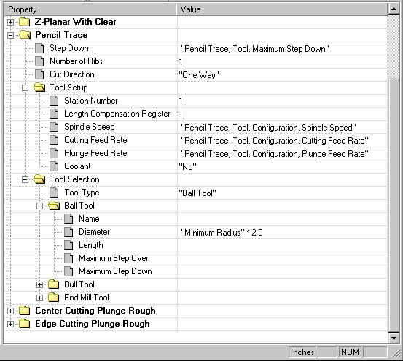
Tool Setup – build rules and expressions for parameters assigned to the tool.
Tool Selection – rules to decide which tool to use.

Insight Tooling Selection

Use Tool Selection to program PowerSource to pick the right tool from the tooling database for machining.

Example: A very simple rule would be to always select a 4” X .25R bull cutter for Z-planar roughing.

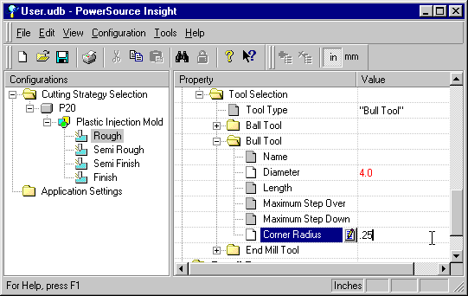
First specify the type of tool to use
Then enter the desired Diameter and Corner Radius

This example programmed PowerSource to recommend to us a 4” X .25 R bull cutter anytime we are doing Z-Planar With Clear roughing for a P20 Plastic Injection Mold.

When you use Prospector, anytime this condition occurs, PowerSource will search your tooling database looking for this tool.
Insight Tooling Selection

- Always select a type of tool. You may also program a rule that picks the type of tool based on current machining conditions.
- Only fill in those items that are most important to the tool selection criteria. Leave non-critical factors empty.
- Empty fields will not factor into the tool selection process.

What if we have two tools with an exact match for the programmed diameter and corner radius?

It’s a tie – one of the tools will be picked at random unless we add a tiebreaker condition.

If we are doing Z-Planar With Clearing for the roughing stage, we would likely prefer a tool with the largest step-over:

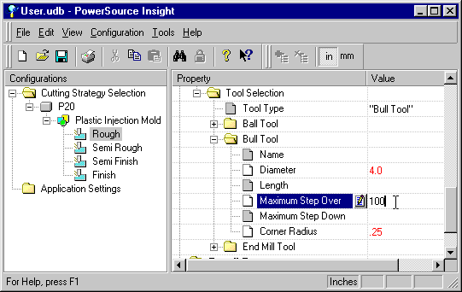
100” is an absurd step-over. This tells PowerSource that the step-over is a consideration but because it does not closely match a step-over in the database, it isn’t a very important factor in decision making.

Insight Tooling Selection

There are many possibilities for tooling selection rules. Ultimately you will want to blend several factors together to influence the correct tool selection. Some examples of rules that are easily programmed into PowerSource include:

- Pick a tool that is the correct size for the window (the tool needs to fit in the window). What’s a good “window size to tool size” rule?
- When doing finish lace cuts, use a bull or flat cutter if the surface model in the window is very flat otherwise use a ball cutter. What is very flat?
- Choose a cutter long enough to reach the bottom of the job inside the window (highest surface point minus lowest surface point) so the holder and adapter won’t interfere with the stock.
- Choose a cutter with the largest step-over and step-down for Z-Planar with Clearing for the rough stage of machining.
- Choose a ball cutter for pencil tracing that is 5% larger in diameter than twice the minimum radius in the window.
- Never select a cutter that can’t ramp in material for Z-Planar With Clearing and Z-Planar without Clearing.
Tool Setup

Once you have addressed Tool Selection, program the Tool Setup section to set the parameter for the tool:

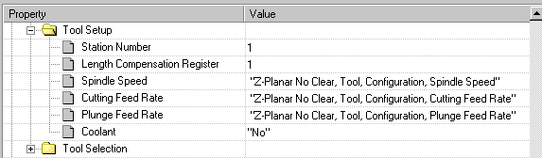
- Usually you will want to use the speeds and feeds from the tooling database for the tool selected.

- Since these feeds and speeds are good starting points, it may make sense to adjust them here to suit the situation. For example, a higher feed rate for finishing than semi-finishing for a given tool may make sense as there is less stock to remove in the finish stage of machining. In this case, add an expression to adjust the finish cutting feed rate upward by 25%.

- Station Number and Length Compensation Register can be programmed using a rule to assign them to specific tools based on the tool name in the database.

Lab Exercise #10

Tool Information

For this exercise use PowerSource Insight to modify your user database to solve the described problems. Use Prospector to verify each rule works as desired.

Exercise A

When I’m doing Lace finish cutting I’d like my tool’s step over to always be 80% of what is specified for that tool’s maximum step over in the tooling database.

Exercise B

When doing Z-Planar With Clearing, reduce the feed rate by 20% if the operator programs a step-over greater than the maximum recommended for the tool.

Exercise C

When I’m doing Z-Planar No Clearing in Semi-Rough I always want to use a Bull cutter. It should suggest the tool that has a diameter closest to 1% of the area of the window and a corner radius closest to the minimum radius within the window.

Exercise D

When I’m doing Z-Planar With Clearing and using Off-the-Block Z-Level transition and my cavity strategy is do not cut, I want to use a plunge feed rate of 400 (not cutting any material) otherwise use the tool’s maximum plunge feedrate.

Exercise E

For lace machining, increase the cutting feed rate of the tool in inverse proportion to the step-over value used for machining. For example, if the operator enters a step-over than is ½ of the maximum recommended step-over, increase the feed rate by 50%.

Final Exam

True or False?
1 | PowerSource is an application program.
2 | PowerSource allows Prospector to be tailored to react to changing conditions.
3 | PowerSource feeds Prospector information only when Prospector is first started.
4 | Prospector provides PowerSource with information at runtime such as the amount of remaining stock and window information.
5 | The PowerSource Insight application can be used to edit tooling definitions.
6 | PowerSource databases are binary files and can only be edited through use of the Insight and Tooling applications.
7 | Inch and Metric information is stored in separate databases.
8 | You may override any property in a user database as long as it isn’t locked in the system database.
9 | You must have Windows NT administrative privileges to make any changes to either the User or System PowerSource database.
10 | Only when editing a system database is it possible to lock a property.
11 | New materials can be defined in the user database.
12 | New configurations can be defined in the user database.
13 | New tools can be defined in the user database.
14 | Lock files are created whenever a database is opened to prevent concurrent access.
15 | A user database can only be used when the same system database from which it was created is available.
16 | Every Prospector project must reference a PowerSource configuration.
17 | When a project is created the PowerSource information is extracted from the database and stored permanently with the project.
18 | Prospector, Insight and Tooling all have on-line help manuals.
19 | You can use the “What’s This?” style help to find out the definition of each PowerSource property.
20 | Application Settings can be modified only in the system database.
21 | When editing the user database, values shown in red indicate that they have been changed from the defaults provided in the system database.
22 | Application Settings are system wide properties not specific to any one configuration.
23 | In Insight each configuration has the identical list of properties but with different rules that are appropriate for each.
24 | A property is an individual element of PowerSource that can be assigned a value.
25 | Properties can be one of three types: String, Numeric or Choice List.
26 | String values must always be enclosed in double quotes.
27 | Numeric values must always be enclosed in quotes.
28 | Only a single selection from a drop down Choice List is allowed.
29 | You may only create or delete a configuration from within a system database.
30 | When a new configuration is created, it is created for both inch and metric.
31 | New configurations can be created by simply copy and paste of an existing configuration.
32 | Deleting a material will also remove any tooling configurations based off the material that you delete.
33 | Deleting a configuration will also delete any user overrides in user databases created from this system database.
34 | Locking a property locks it for all configurations, all machining stages and both systems of units.
35 | When a property is locked it can be changed in the user database only if you have Administrator privileges.
36 | Inside Prospector you can change which user database to use but this only effects the current project.

37 | Two different NT Workstation logins could point to two different User databases.
38 | When creating a new program, PowerSource property values may be changed on the last page of the New Program wizard as long as they are not locked.
39 | Correct implementation of PowerSource databases requires an up-front analysis of your shop practices.
40 | You should design your database implementation such that as many common and shop-wide configurations are centralized into a single system databases.
41 | Making a change to the system database within Insight automatically propagates those changes to the associated user databases.
42 | Once a user database is created it is forever married to that particular system database it was created from.
43 | Changes made to the tooling definitions within the system database will automatically propagate to the associated user databases.
44 | In PowerSource Tooling I can specify multiple cutting feed rates for a tool… one for each material type.
45 | I must exit and re-start Prospector to get any changes made to my PowerSource database.
46 | I need to run Prospector to manually verify each PowerSource rule or expression that I make.
47 | I can easily tell that there is a rule associated with a property by the look of the icon in front of the property.
48 | When creating a rule the Rule Builder will automatically check for logic errors.
49 | Each rule or expression that I create is used for both inch and metric situations.
50 | The edit pane of the Rule Builder color-codes properties and functions for easy identification.
51 | When editing the user database there is no way to get back the default value once you’ve changed it.
52 | I can use logical operators when building an expression.

53 | When building a rule you must always have a default condition.
54 | When a rule is evaluated, the conditions are evaluated from top to bottom.
55 | Insight will discover and report syntax errors at the time the rule or expression is being created.
56 | A syntax error happens when a rule or expression does not follow correct VBScript syntax.
57 | PowerSource is able to detect some types of logic errors at runtime but other are found only by testing new rules and expressions inside Prospector.
58 | You can use Insight’s Find command to quickly jump to the exact property that generated an error.
59 | Tool Selection properties are used to tell PowerSource how to select a correct tool for the given cutting strategy.

